ish¿u ysñlï weúßKs $ All Rights Reserved

St. Peter's College

St. Peter's College

St. Peter's College

புனித பேதுரு கல்லூரி

புனித பேதுரு கல்லூரி

புனித பேதுரு கல்லூரி

புனித பேதுரு கல்லூரி

புனித பேதுரு கல்லூரி

புனித பேதுரு கல்லூரி

புனித பேதுரு கல்லூரி

புனித பேதுரு கல்லூரி

Ydka; mS;r úÿy,

Ydka; mS;r úÿy,

Ydka; mS;r úÿy,

Ydka; mS;r úÿy,

Ydka; mS;r úÿy,

Ydka; mS;r úÿy,

Ydka; mS;r úÿy,

Ydka; mS;r úÿy,

Ydka; mS;r úÿy,

Ydka; mS;r úÿy,

St. Peter's College

St. Peter's College

St. Peter's College

St. Peter's College

St. Peter's College

St. Peter's College

St. Peter's College

St. Peter's College

St. Peter's College

St. Peter's College

புனித பேதுரு கல்லூரி

புனித பேதுரு கல்லூரி

புனித பேதுரு கல்லூரி

புனித பேதுரு கல்லூரி

புனித பேதுரு கல்லூரி

புனித பேதுரு கல்லூரி

புனித பேதுரு கல்லூரி

புனித பேதுரு கல்லூரி

Ydka; mS;r úÿy,

Ydka; mS;r úÿy,

Ydka; mS;r úÿy,

Ydka; mS;r úÿy,

Ydka; mS;r úÿy,

Ydka; mS;r úÿy,

Ydka; mS;r úÿy,

Ydka; mS;r úÿy,

Ydka; mS;r úÿy,

Ydka; mS;r úÿy,

St. Peter's College

St. Peter's College

St. Peter's College

St. Peter's College

St. Peter's College

St. Peter's College

St. Peter's College

86

E

**I,II**

**YdÍßl wOHdmkh**

**Physical Education**

**meh 01**

**One Hour**

**10 fY%aKsh – m<uq jdr we.hsu - 2024**

***Grade10 – First Term Examination - 2024***

Ydka; mS;r úÿy, - fld<U 04

புனித பேதுரு கல்லூரி, கொழும்பு 4

***St. Peter's College - Colombo 04***



Name: ''''''''''''''''''''''''''''''''''''''''''''''''''''''''''''''''''''''''''''''''''''''' Class: '''''''''''''''''''' No: ''''''''''''''''''

**Part - I**

* **Use the following information to answer questions 01 to 03.**

🟋 Amal is the captain of the basketball team and he is very famous among others. Amal is very sensitive to others and has an ability to engage in sports without any fatigue.

🟋 Ruwan is a good volleyball player and he always blames his team mates, because he needs to win the match any how.

🟋 Waruni is a obese girl and she expends more time to read books.

🟋 Tharushi comes to school early in the morning. After cleaning the classroom, she stays alone in the classroom.

01. Who has built a total health status according to above information?

i. Amal ii. Ruwan iii. Waruni iv. Tharushi

02. Which quality should be developed by Ruwan?

i. Physical and mental wellbeing. ii. Mental and social wellbeing.

iii. Social and spiritual wellbeing. iv. Spiritual and physical wellbeing.

03. Who needs advice to improve the physical wellbeing?

i. Amal ii. Ruwan iii. Waruni iv. Tharushi

04. A defect which occurs due to bending backwards of the upper part of the vertebral column is a unusual __________.

i. Kyphosis ii. Scoliosis iii. Lordosis iv. Flat back

05. 🟋 Keeping the spine vertically

🟋 Wasit , knees and ankles should be bent at

🟋 The soles of the feet should be touched the Flore.

Above instruction should follow in,

i. Incorrect standing ii. Incorrect sitting iii. Correct sitting iv. Correct standing

06. Positioning the body in a static or dynamic movement with less pressure on the muscles and the bones is called:

i. Posture ii. Static posture iii. Dynamic posture iv. Correct posture

07. Select the dynamic movement from following.

i. Standing ii. Sitting iii. Lying iv. Running

08. The information given below is about a certain game. What is it?

* Willium G. Morgan
* 1916

i. Volleyball ii. Netball

iii. Football iv. Cricket

09. Sri Lanka became the world champions of the game,

i. Volleyball ii. Football iii. Hockey iv. Cricket

10. The psycho-social quality which improves when we engage in outdoor activities,

i. Development of bones and muscles coordination.

ii. Development of physical fitness.

iii. Getting used to adopt correct posture.

iv. Being able to manage stress.

11. Which of the following is a common feature of organized games?

i. Leaning to spend the leisure effectively.

ii. Less expensive.

iii. Three are accepted rules and regulations.

iv. It is not necessary to have playgrounds according to standard measurements.

12. Which helps to maintain posture?

i. Length of the legs ii. Length of the arms

iii. Center of gravity iv. Height of the person

13. A person standing straight with hands by the side will have center of gravity at a distance of the table height measured from the ground.

i. 60% ii. 56% iii. 70% iv. 48%

14. When seated, the center of gravity is situated _________.

i. On the knee ii. On the hip iii. On the legs iv. On the shoulder

15. The duration of a single round in a game of football is:

i. 30 mins. ii. 60 mins. iii. 45 mins. iv. 20 mins.

16. Which is considered a foul in volleyball?

i. Service ii. Spiking iii. Double contact iv. Setting

17. An event commenced with crouch start is:

i. $800m$ ii. iii. iv.

18. Which is a horizontal jumping event?

i. High Jump ii. Pole Vault iii. Long Jump iv. Jumping Jacks

19. When approaching to spiking the second step should be placed _________ the first step,

i. Closer than ii. Equally iii. Further than iv. Non of the above

20. When feet are kept together the balance of the body is __________.

i. Increased ii. Decreased iii. Not changed iv. Doubled

**(20 Marks)**

**Part – II**

* **1st and 2nd questions are compulsory.**
* **Select one from the 3rd and 4th questions.**

01. i. Name the two factors of bio mechanics that affect posture. **(02)**

ii. Write four factors that help to maintain “balance”. **(02)**

iii. Explain “Center of gravity”. **(02)**

iv. What are the factors to be considered when “standing correctly”. **(02)**

v. Briefly explain the correct posture of “sitting on a chair”. **(02)**

**(10 Marks)**

02. **Volleyball**

i. Write three special features of volleyball which have made it popular. **(02)**

ii. Name the skill displayed in the following picture and write five other skills of volleyball. **(03)**

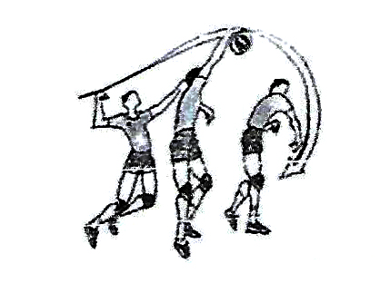

iii. Name three fouls committed during spiking. **(02)**

iv. What are the four stages of blocking? **(01)**

v. Name the officials required to officiated a volleyball match. **(02)**

**(10 Marks)**

03. **Netball**

i. Name the positions of members of a netball team in a court. **(03)**

ii. Name the skills displayed in the following picture and write four other skills of netball. **(03)**

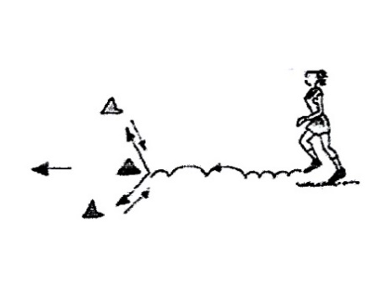

iii. Mention two activities that make shooting successful. **(02)**

iv. Write the occasions when the ball is tossed between two players in netball. **(02)**

**(10 Marks)**

04. **Football**

i. Name four types of kicks used in football. **(02)**

ii. Name the skill displayed in the following picture and write three another skills in football. **(03)**

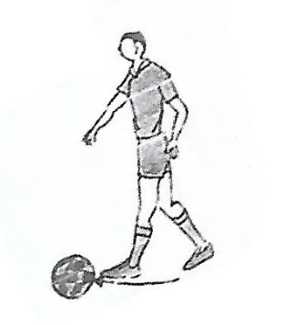

iii. Write three responsibilities of the main referee in a football game. **(03)**

iv. Mention an activity to practice “controlling the ball” for a beginner of an U-14 team. **(02)**

**(10 Marks)**